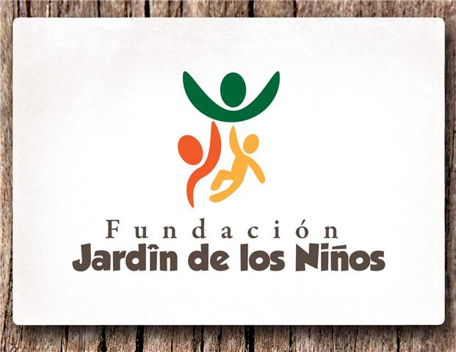
CHILD SPONSORSHIP FORM

Name of Sponsor:_______________________ Phone:_____________
Address:_______________________________City:______________
State:_____________Zip:_____________Email:_________________
Amount of monthly sponsorship:_________________Start Date:______
Sponsorship amount will be paid on the __________day of each month.
Special requests:_____________________________________________________________________________________________________________________________________________________________________________________________________________________
Childs Name:____________________________Age:______________

Signature:________________________________

*The cost of care for one child is approximately $400 per month. Therefore the money that you are committing to this child is used together with his/her other sponsors for the direct care of this child. It goes towards food, clothes, diapers, any special medications or equipment the child may need.

